Exhibition Showcases Five Decades of Michael Graves’ Designs at Home and Abroad

October 24, 2014 12:25 PM

Grounds for Sculpture in Hamilton, New Jersey has mounted a retrospective as part of the architect, designer and painter Michael Graves’ 50th-anniversary extravaganza taking place this fall. Writer Nancy Lazarus visited the multimedia exhibition and then visited the Graves home and studio, aka “The Warehouse,” in Princeton.

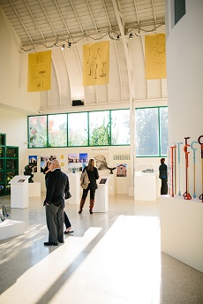Golden banners hung from the rafters and bearing sketches of now-famous products greet visitors to Michael Graves: Past as Prologue at the Grounds For Sculpture. The retrospective, on view through April 5, is a festive tribute to Graves and his architecture and design firm as they mark their fiftieth anniversary.

Organizing an exhibit spanning Graves’ prolific and ongoing career was no easy feat. “This was planned as a series of vignettes” chronicling the practice’s interdisciplinary work along with Michael’s own drawings and paintings, explained Karen Nichols, principal at Michael Graves & Associates, at a recent press preview. The firm’s core values: aesthetics, functionality, and humanistic design, connect seemingly disparate projects.

Few architects can claim commissions as varied as the Portland Building, Louisville’s Humana Building, the Denver Library, decorative scaffolding for the Washington Monument, various Disney Resorts, and Resorts World Sentosa in Singapore. The photographs and architectural models tell the stories of Graves’ broad geographic scope.
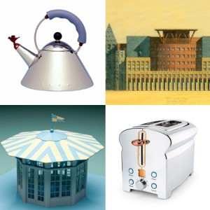Much exhibit space is devoted to Graves’ product design collaborations, and the whimsical Alessi products are the ultimate expression of his aesthetic. Donald Strum, principal at Michael Graves Design Group, said when the Alessi sterling silver tea set toured museums and galleries, Graves’ items sold best. Alberto Alessi once remarked that Michael had a way of tuning into consumers’ tastes. The tea kettle is highly coveted—to the point that its bird whistle is frequently stolen from Alessi stores.

For Steuben Glass, Graves made a three-dimensional version of a Juan Gris painting by converting it into a small table, and he created a playful and popular toaster for JCPenney that’s shaped like a loaf of bread. When Graves collaborated with Target on a line of housewares, the goal was to use design to differentiate the brand’s everyday items from its competitors. Models and prototypes were studied and produced to see how they’d look in peoples’ hands, explained Strum.
For the past decade, since an illness left Graves partially paralyzed, he’s refocused his efforts on healthcare. Here function and aesthetics are paramount, Nichols said. The firm does research to understand the experience of end users, so products work better. Among items designed to date are ergonomic wheelchairs for Stryker Medical and brightly colored, adjustable canes for Kimberly-Clark. As Graves once commented, “I use color. It’s not to get you well, but to make you smile.”
Of all Graves’ projects, his home, known as “The Warehouse,” in Princeton, has been among the most personal and challenging, and that’s where the press preview continued. Built in 1927 in Tuscan vernacular style, the L-shaped structure contains 44 rooms. The house has become a repository for his favorite collectibles, including Biedermeier furniture and Corot paintings. Graves told the group about an earlier conversation when an interviewer asked him, “What do you want out of your practice?” Graves said he replied, “I just want to finish my house”

Nancy Lazarus is a frequent contributor to UnBeige.

